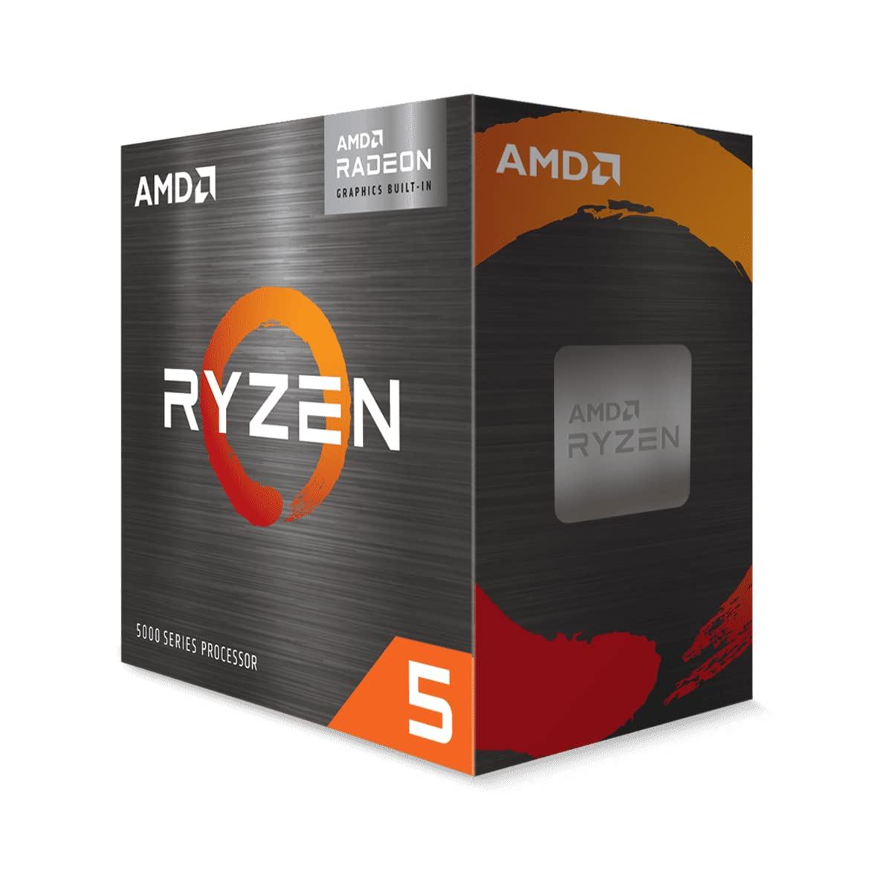

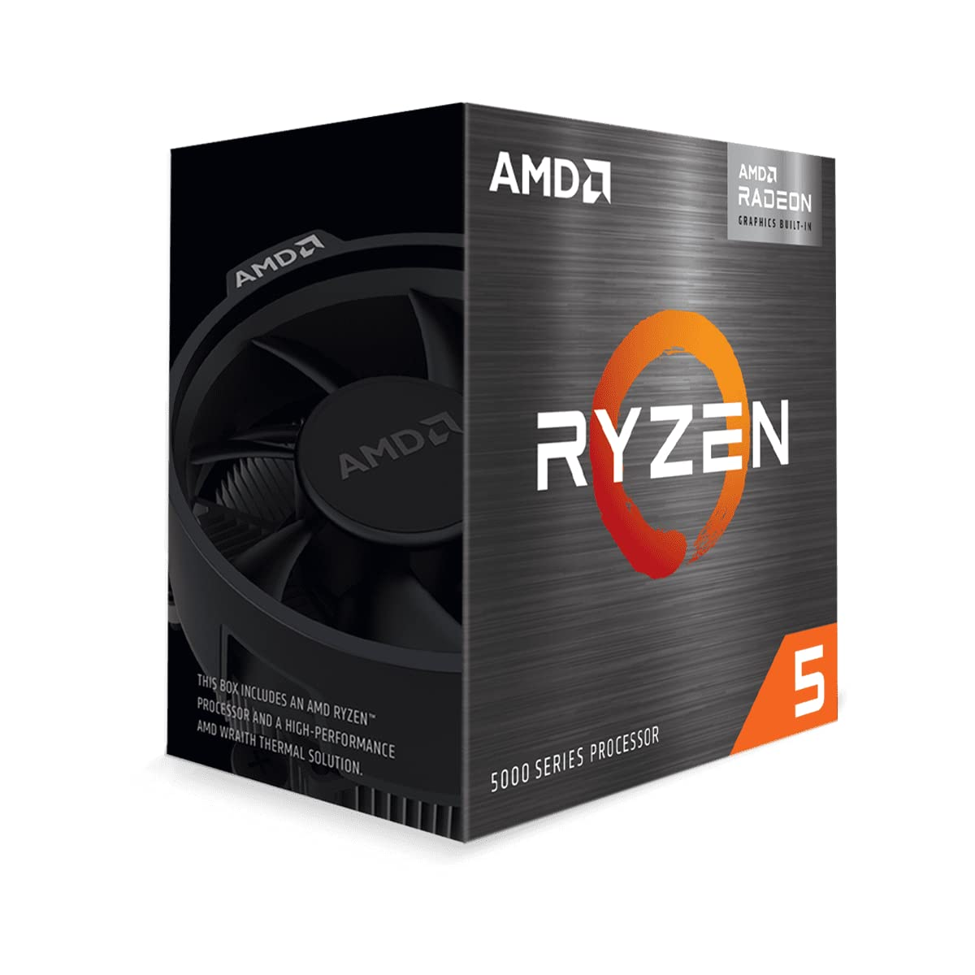

AMD Ryzen™ 5 5600G Desktop Processor (6-core/12-thread, 19MB Cache, up to 4.4 GHz max Boost) with Radeon™ Graphics

|  |  |
| --- | --- |
| M.R.P.: | ₹34,500.00 |
| Deal of the Day: | ₹15,800.00   |  |  | | --- | --- | | Brand | AMD | | CPU Manufacturer | AMD | | CPU Model | Ryzen 5 | | CPU Speed | 3900 MHz | | CPU Socket | Socket AM4 |  About this item  * 6 Cores & 12 Threads, 19 MB Cache. Turbo Boost :Yes * Base Clock: 3.9 GHz, Max Boost Clock: up to 4.4 GHz. Virtualization Support: Yes * Memory Support: DDR4 3200 MHz, Memory Channels: 2, TDP: 65W * Compatible with Motherboards based on 500 series chipset, Socket AM4 * Graphics: AMD Radeon Graphics, Included Heatsink Fan: Wraith Stealth * 3 Years Brand Warranty. For Technical Support : Please Contact : Tel: +91-80-67030050 (Mon-Fri: 09:00 - 17:00 IST); Expect Delayed Response due to ongoing COVID Crisis * For all performance-related issues in: AMD Processor: Please reach out via AMD brand home page > Drivers & Support > Customer Support  (Technical & Warranty help) > Contact Support > Online Service Request In case you are not satisfied the resolution provided by the above brands, please reach back to Amazon Customer service for next steps. |